
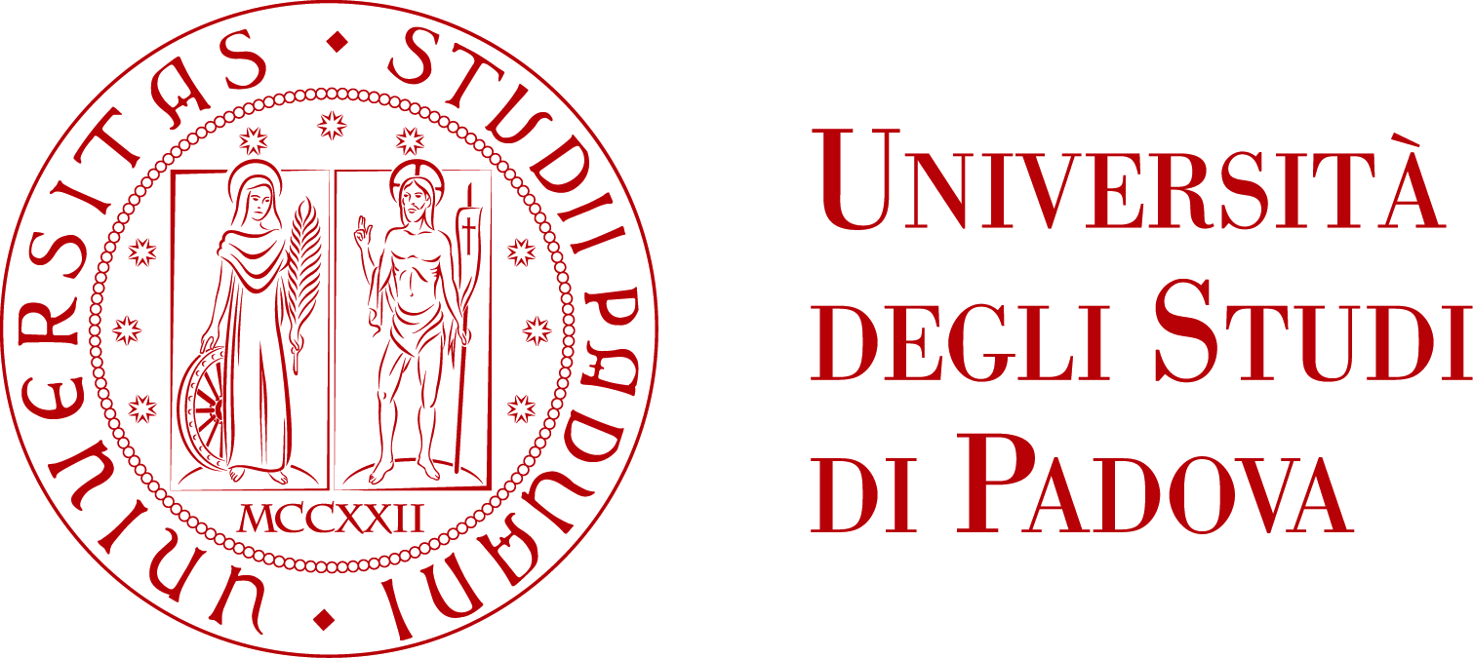

International Winter School
Biodiversity, Ethnoecology and Bioprospecting in Nepal Himalaya
Kathmandu (Nepal), January 29th – February 8th 2017

APPLICATION FORM

Personal details
Family name ____________________________ First name _____________________________
Middle name ____________________________ Date of birth (dd-mm-yy) _____/_____/______
Gender M ⃝ / F ⃝
Permanent address : Street address ________________________________________________
Town _________________________ ZIP ______________ Country _______________________
Nationality __________________________
Telephone ___________________________ Email ___________________________________
Codice Fiscale (Italian applicants only) ______________________________________________
Foreign taxpayer reference/identification number (if any) ______________________________

Eligibility
Highest academic degree (bachelor B.Sc. /master's M.Sc. /PhD) __________________________
_________________________________ Institution ___________________________________
Graduation year ______________________
Attachments
- Curriculum vitae (.doc; .docx; .pdf)
- Copy of academic diploma (.jpg; .pdf)
- Brief motivation letter (approximately 500 words)

Privacy and Data Protection
- I declare that the information given above is accurate.
- I agree to provide upon request all necessary documents and transcripts.
- I agree to the use of the above information in accordance to the Titolo III, capo I and II of Italian decree D. Lgs. 30 June 2003 n. 196 on Privacy and Data Protection for the purpose of fulfilling the obligations arising from the contract between myself and the University of Padova.

Date: _______/_________/_____________

Signature: ________________________________

